**CN LAB 5 REPORT**

**Experiment Overview:**

In this experiment, you will configure static and default routing on routers to enable

communication between different network segments. Using Cisco Packet Tracer, you will create

a network with multiple routers and PCs, and configure routing to ensure proper data transfer

between devices.

**Procedure:**

**Network Design:**

● Router1 connected to Router2.

● PC0 connected to Router1.

● PC1 connected to Router2.

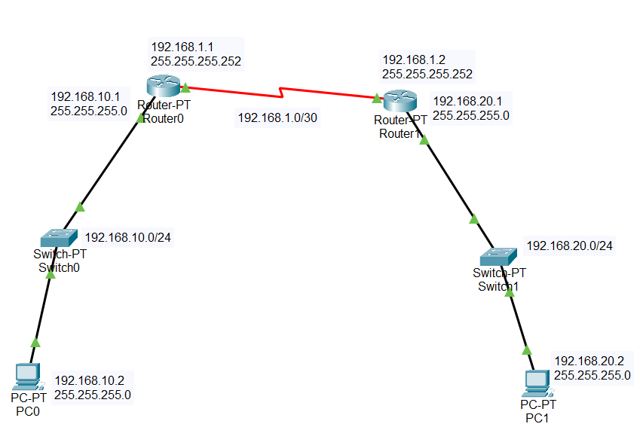

**Step 1:** Select and drag required network devices (2 Router-PTs, 2 2960-24TT Switches) and end devices (2 PC-PTs).

**Step 2:** Open Routers and add PT-ROUTER-NM-1CFE and PT-ROUTER-NM-1S Modules.

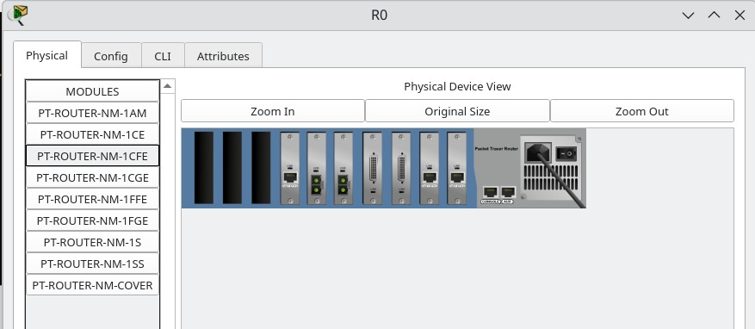

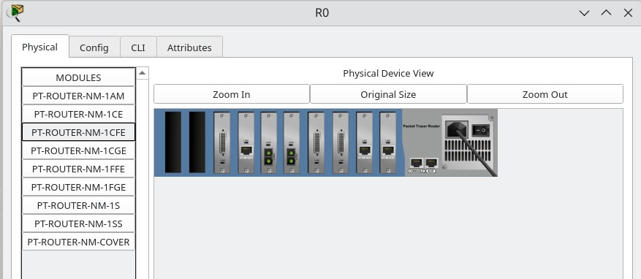

**Step 3:**

Connect the cables (Straight through cables for different devices) and Serial DCE (between routers).

**Step 4:**

Open the routers CLI and type in the following commands (R0)

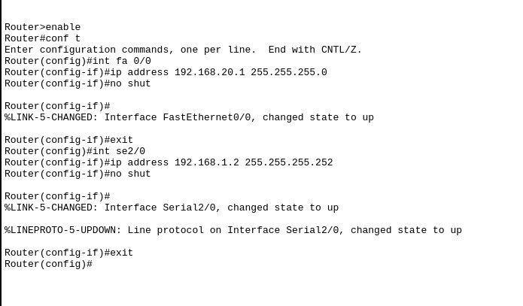

Similarly do it for R1.

**Step 5:** Configure IP addresses for PC1 and PC2

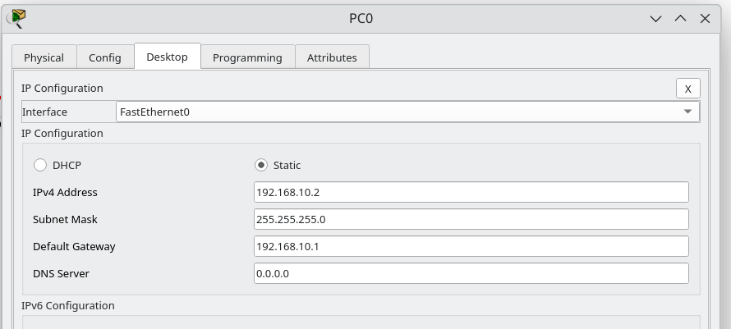

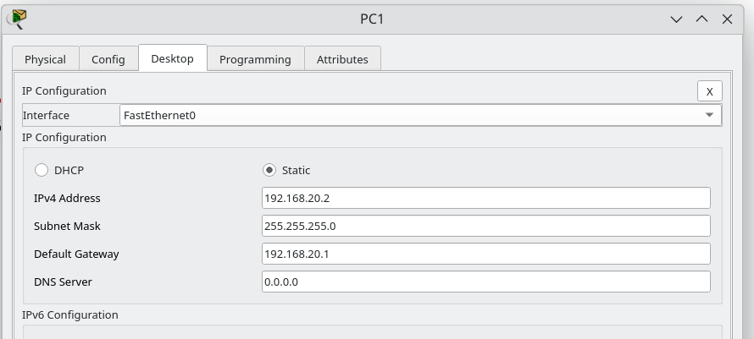

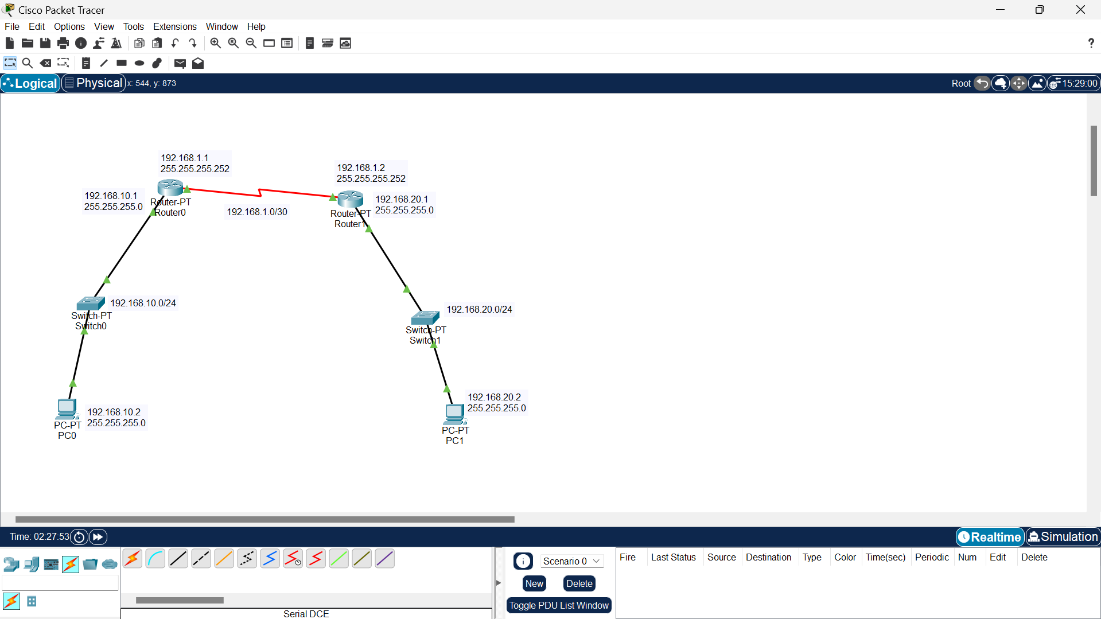

Step 6:

Configure Static Routing and Default Routing for Routers.

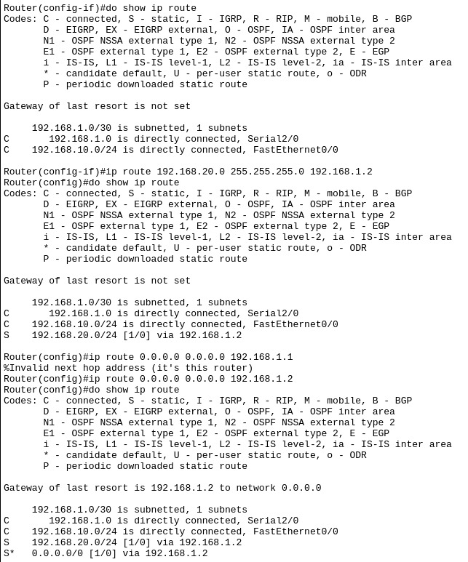

This is for R0, Implement the similar for R1 (default and static pointing to R0).

**Simulation:**

Pinging PC1 from PC0

ICMP ECHO RESPONSE:

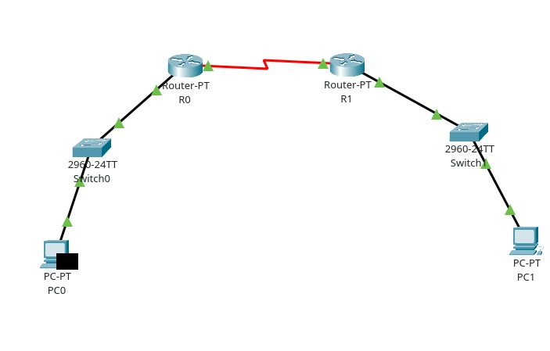

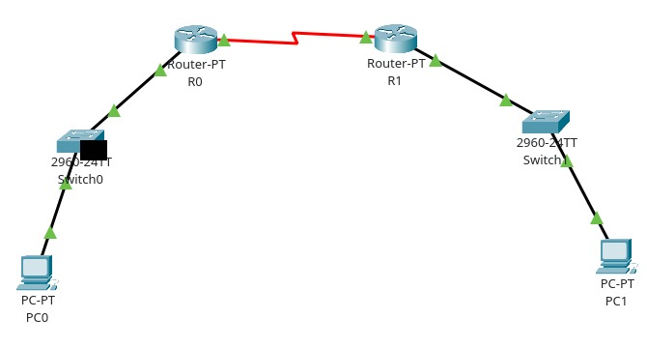

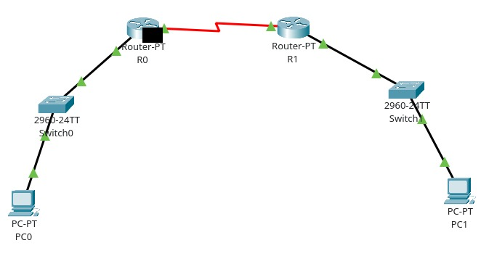 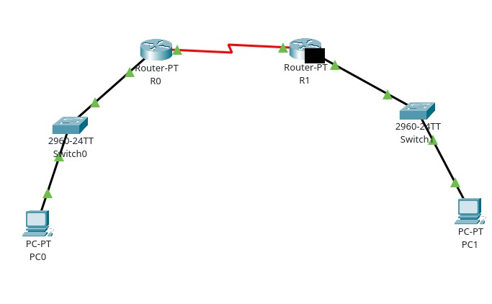

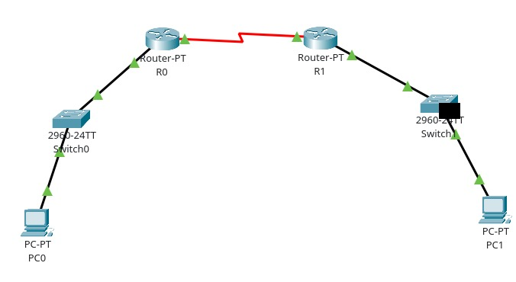 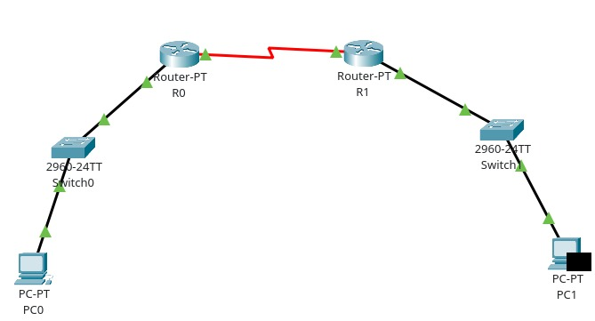

ICMP ECHO REPLY:

